Social Script
Intake at Drummond Street Services

Last updated: Monday, 22 May 2023

This Social Script describes the Intake process at Drummond Street Services. You can read through the whole document or go to the part you want to know more about by clicking the relevant link below:

- How to access Intake
- How you can make Intake accessible
- What to expect during Intake
- What to expect at the end of Intake
- What to expect after Intake

How to access Intake:

An Intake at Drummond Street Services is a session with an Intake Worker that helps us work out what service, program or worker would be best for you.

Intake sessions often happen before you can have an appointment with someone or join a program or service.

You can access Drummond Street Services Intake in 4 different ways.

- Over the phone, when you call Drummond Street Services on 03 9663 6733. You will need to speak to Reception or leave a voicemail with your details. You can include:
  - Your name
  - Your contact details
  - When would be a good time for you to be called back

- Submitting our online form via THIS LINK. This form will ask questions about you, your identities and what support you are looking for.

- By referral, when your professional support refers you to Intake. They should call 03 9663 6733 or email intake@ds.org.au and refer you to Intake.

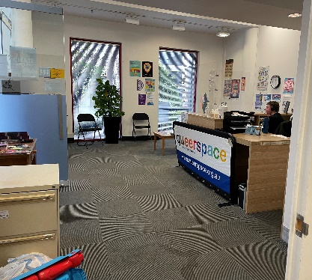
- Request an Intake in-person, when you come to the Drummond Street Services Carlton office (100 Drummond Street, Carlton VIC 3053) and ask the receptionist that you want to do an Intake. The Intake team will then email or call you to book later. You can find more information about the building in our Access Key via this link: https://ds.org.au/wp-content/uploads/2023/03/Access-Key-for-Service-Users-100-Drummond-Street-Carlton-Final-Updated-230323.pdf

Once you have provided your details or your referrer has provided your details, Drummond Street Services will then try and contact you to find a time to do the Intake. It might take up to 7-10 business days for Drummond Street Services to call you back.

Before your Intake call, you might like to think about what you want to talk about, as well as if there is anything you don’t want to talk about.

How you can make Intake accessible:

Intake is usually done over the phone, but you could also:

- Do a video call

- Use Auslan Interpreters

- Do a live chat via messaging on Zoom

- Meet at the Drummond Street Services Carlton office

- Provide the information by email

You can let the Intake Workers know if there are others things that will make Intake accessible for you.

You could do this by:
- Letting the Intake Worker or receptionist know your access needs when you call or come to the office
- Including your access needs in the online form under ‘What is the main reason you are contacting us?’
- Asking the person who referred you to let us know your access needs
- Emailing enquiries@ds.org.au with your access needs

You can ask for anything, and the Intake Workers will try and find a way to make that work. They want to help make Intake safe and appropriate for you.
What to expect during Intake:

‘Expect’ means what might likely happen in a situation for you.

Someone from Drummond Street Services’ Intake team will contact you via your preferred method you.

If the Intake is a call, you might like to do the call when you are in a place where you feel safe and can focus on the conversation.

At the start of the Intake session, the Intake Worker will go through some information such as how long waitlists are, where sessions might be or what support for you might look like.

They will also:
- Let you know they will be creating a ‘case’ for you and will be typing down notes as you speak
- Need your consent, or permission, to write down your information
- Ask questions to help them understand what is going on for you
- Let you know they will add you, and anyone you attend a session with, as a client

This conversation usually takes between 25 and 40 minutes. It can sometimes be longer or shorter depending on how much information you tell the Intake Worker.

You don’t have to answer all of the questions they ask you. If the Intake Worker asks you a question you don’t want to answer, you can just say “I don’t want to answer”, and they will move on to the next question.

Some of the questions the Intake Worker might ask you are:
- What is your name?
- How do you identify? (for example, queer, disabled, recent migrant etc.)
- Where are you living?
- What are your access needs?
- What do you need in a service?
- What have you experienced in the past? (for example, experiences with services, relationships, culture etc.)

They might also ask you about things to do with your safety. This might include:
- If you have experienced family violence, either currently or in the past
- Your mental and physical health, including struggles and/or safety concerns you might have
- What formal and informal supports you have
- If you have any legal concerns that impact you
- If you are taking care of any children

You can provide long or short answers. You can say “I don’t want to answer” to any of these questions.

What to expect at the end of Intake:

Before the Intake Workers ends the call, they might:
- Ask you what your availability for a session with a Practitioner is
- Review the waitlist and tell you how long the waiting list to see a Practitioner is
- Tell you that some services are free and that some cost money
- Ask if you want any extra information about other options or supports
- Talk to you about self-care strategies to do after the call

The Intake Worker might also offer you ‘holding calls’ to check in with you every couple of months after your Intake call.

What to expect after Intake:

When they have a spot or appointment for you, a Practitioner will reach out to you to set up a session. This can be a while after your Intake session.

You will then begin working with the Practitioner. You can find out more about what working with a Practitioner is like in the ‘Interacting with a Practitioner’ Social Script.

