Social Script
First Contact with Drummond Street Services

Last updated: Monday, 8 May 2023

This Social Script describes the experience of first contacting Drummond Street Services. You can read through the whole document or go to the part you want to know more about by clicking the relevant link below:

- Your first contact with Drummond Street Services
- What to expect when you visit in person
- What to expect from reception
- How to be referred to the right person at reception
- What to expect when you are finished at reception
- What to expect when calling on the phone
- What to expect when someone answers the phone
- What to expect after your first contact with Drummond Street Services

Your first contact with Drummond Street Services:

You can contact Drummond Street Services in 2 different ways.
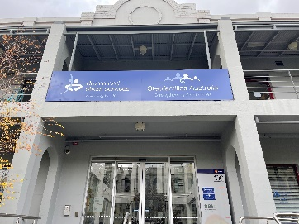
- In person, where you would visit the physical space located at: 100 Drummond Street, Carlton 3053.

- Over the phone, when you call: 03 9663 6733

You can contact us whichever way feels best for you.
Drummond Street Services is open at these times for in person visits or phone calls:
- Monday from 9am to 5pm
- Tuesday from 9am to 8pm
- Wednesday from 9am to 8pm
- Thursday from 9am to 5pm
- Friday from 9am to 5pm

Opening times may change due to public holidays.

What to expect when you visit in person:

Drummond Street Services is located at 100 Drummond Street, Carlton 3053.

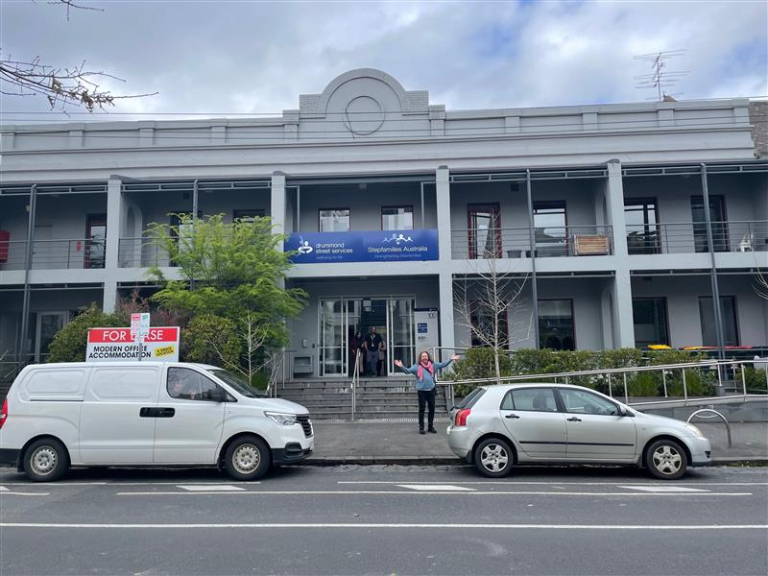

Drummond Street is a long street with a mixture of residential and business buildings. The Drummond Street building has stairs and a ramp to get inside.

You can find more about the building in our Access Key via this link: https://ds.org.au/wp-content/uploads/2023/03/Access-Key-for-Service-Users-100-Drummond-Street-Carlton-Final-Updated-230323.pdf

You can bring someone with you if you like.

Once inside the building, you will need to enter the foyer and turn left to find our reception desk and waiting room.

In reception there is:
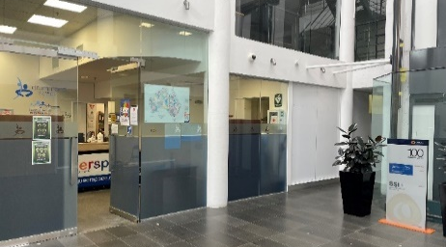
- A receptionist sitting at a desk with a clear plastic covid screen
- A waiting room with seats you can sit on to wait if it is busy
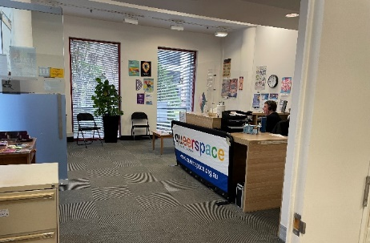
- Brochures and information on many topics which are free for you to read or take
- No music playing in the room

The receptionist will let you know when they are free to talk to you.

What to expect from reception:

The receptionist will:
- Ask you a question like “How can I help you today?”
- Try to help, but if they can’t they will refer you to someone who can or help you book an Intake session

You can let the receptionist know if you need anything to make you feel more safe in the space or able to talk to them.

Your first contact with Drummond Street Services might lead to an Intake session if you are looking for support or to join a program, service or group.

An Intake session is usually completed before you can make an appointment for a service, program or group. You can find out more about Intake in the ‘Intake at Drummond Street Services’ Social Script.
How to be referred to the right person at reception:

To be referred to the right person or Intake, the receptionist will ask you a few questions.

You do not have to answer them all if you do not want to, but they will need contact details to let you know when your appointment will be.

The details they will ask for are:
- Your first name
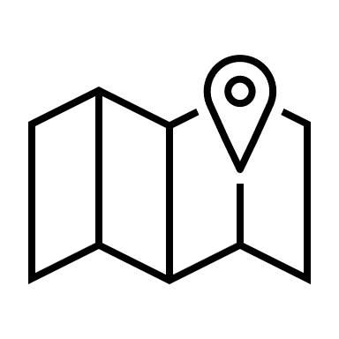
- What suburb you live in
- Your phone number and/or email address
- Whether it is safe for them to leave a voice message or text message
- When the best day and time is to call

This information will be given to the right person or the Intake Team who will contact you as soon as possible to make an appointment with you.

It usually takes 7-10 business days for someone to get back to you.

If it is urgent, we may get back to you sooner.

You may be able to talk to someone the day you contact us if you are in danger.

If you are in danger and need immediate help, it is best to call 000.

What to expect when you are finished at reception:

When you are finished, you are welcome to stay in the waiting room for as long as you need.

You can eat or drink in the waiting room and there are toilets on the same floor behind the elevator and stairs in the foyer.

You can ask the receptionist for help directions.

What to expect when calling on the phone:

When you call Drummond Street Services, you will hear a recorded message. This is an automated voice which will say:
- [automated voice] Hello, thank you for calling Drummond Street Services. We appreciate your call. To best direct your call to the right area, please press 1 for Drummond Street Services, 2 for Queerspace, 3 for Stepfamilies Australia or 4 for the Centre for Family Research and Evaluation. To hear these options again please press 9
You will then:
- Listen to the options and decide which one is appropriate for you. If you do not know which option you need, there is also the option to talk to reception
- Use your phone keypad and press the number of the option that is right for you.

Depending on what option you choose, you will hear:
- Option 1: [automated voice] Welcome to Drummond Street Services. To speak to Reception, please press 1. If you are a new client and would like to arrange support, press 2. To leave a voice mail for us to return your call as soon as we can, press 3. if you would like to hear these options again, press 4
  - You will then either hear hold music while someone receives your call, or a prompt to leave a voice mail message

- Option 2: [automated voice] Welcome to Queerspace. To speak to Reception, please press 1. If you are a new client and would like to arrange support, press 2. To leave a voice mail for us to return your call as soon as we can, press 3. If you would like to hear these options again, press 4
  - You will then either hear hold music while someone receives your call, or a prompt to leave a voice mail message

- Option 3: Hold music will play while someone receives your call

- Option 4: Hold music will play while someone receives your call

Your call will be transferred to the right people.

The hold music is gentle marimba-like instrumental music with no singing.

There may be a wait. Stay on the phone and someone will answer you as soon as possible.

What to expect when someone answers the phone:

You will be asked some questions so that we can best help you.

You do not have to answer all these questions, but we will need your contact details so that we can get back to you with an appointment time.

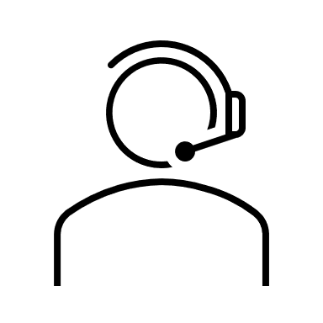
These questions are:
- Your first name
- What suburb you live in
- Your phone number and/or email address
- Whether it is safe for them to leave a voice message or text message
- When the best day and time is to call

This information will be given to the right person or the Intake Team who will contact you as soon as possible to make an appointment with you.

When you have finished talking to the person, you may hang up.

Drummond Street Services will contact you as soon as possible.

It usually takes 7-10 business days to get back to you.

If it is urgent, we may get back to you sooner.

You may be able to talk to someone the day you contact us if you are in danger.

If you are in danger and need immediate help, it is best to call 000.
What to expect after your first contact with Drummond Street Services:

If you were referred to the Intake Team, they will contact you. You can find out more about the Intake process in the ‘Intake at Drummond Street Services’ Social Script.

